Class Diagrams – In Class Activities – Activity Sheet 1

Activity 1
A university wants to develop a simple system to manage students and their courses.
- A Student has a student ID, name, email, and date of birth.
- A Course has a course ID, course name, and credits.
- A student can enroll in courses.
- A course can have many students.
- The system should allow students to register for a course and view their courses.
- The system should allow a course to display its enrolled students.
Task
Draw a UML Class Diagram showing:
- Classes
- Attributes
- Methods
- Relationships between classes
- Multiplicity, if applicable

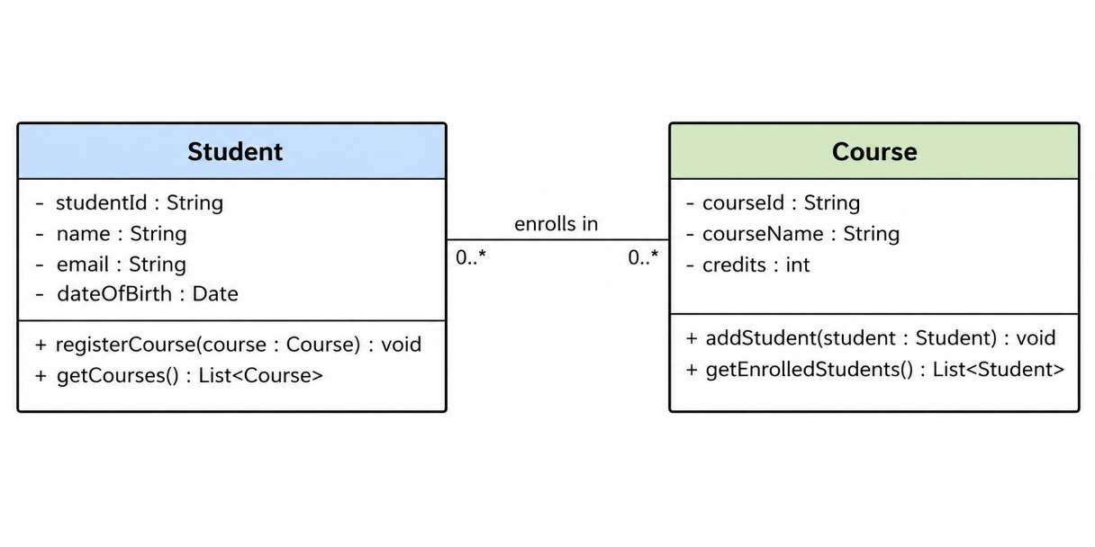

Activity 2
A company wants to develop a system to manage its employees.
- An Employee has an employee ID, name, job title, and salary.
- An employee can manage other employees.
- An employee can have many employees reporting to them.
- Each employee can report to one manager.
- The system should allow an employee to assign a subordinate.
- The system should allow an employee to view their subordinates.
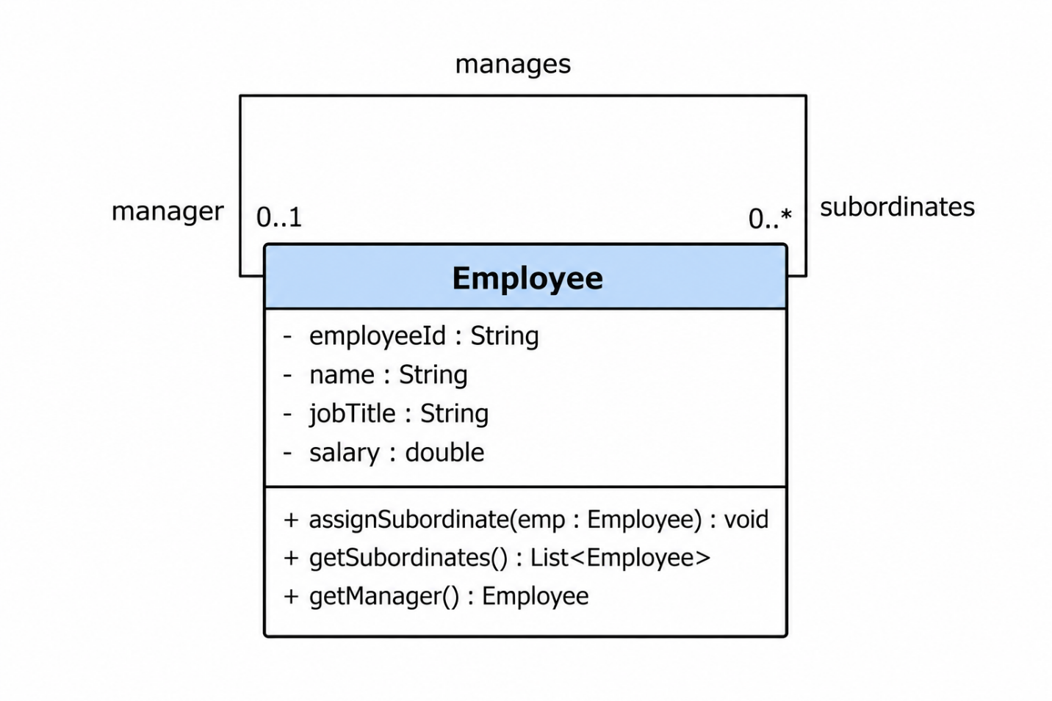

Activity 3
A university wants to develop a system to manage its staff.
- Every Staff Member has a staff ID, name, email, and basic salary.
- A Lecturer is a type of staff member. A lecturer has an additional specialization.
- A Technical Officer is also a type of staff member. A technical officer has an additional technicalArea.
- Every staff member can view their details.
- A lecturer can teach a course.
- A technical officer can manage laboratory equipment.

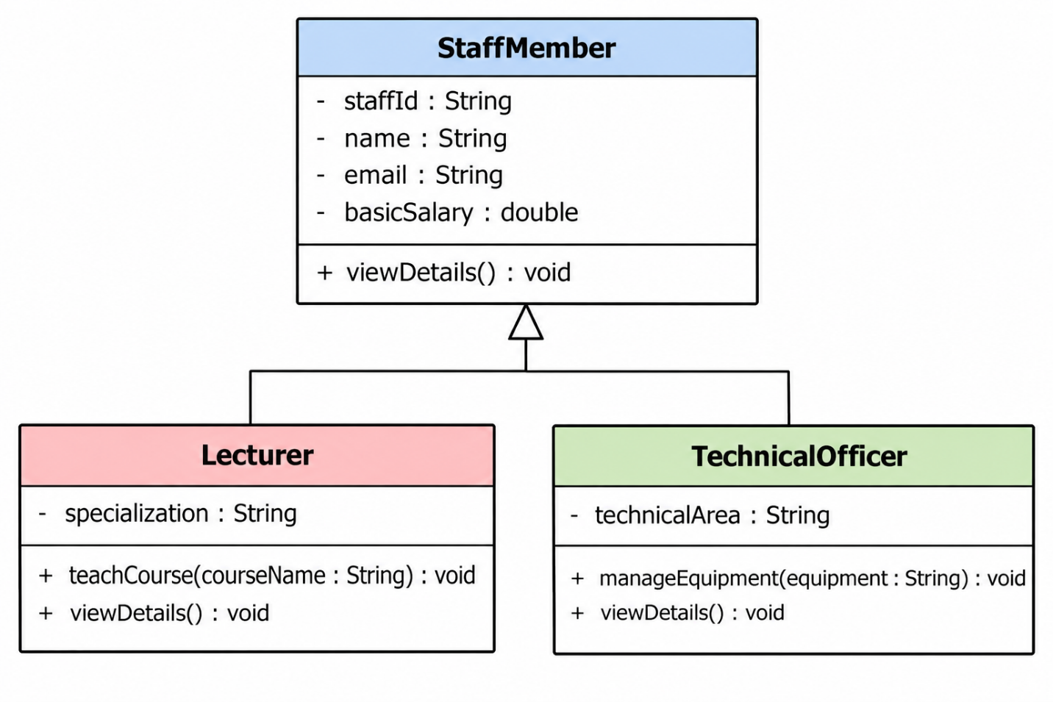

Activity 4
A company has several Departments. Each department has a department ID, name, and location.
- A department has multiple employees.
- Each employee belongs to one department.
- An Employee has an employee ID, name, email, and salary.
- Employees can work on projects.
- A department can exist even if there are temporarily no employees.
- An employee can exist independently of a particular department.

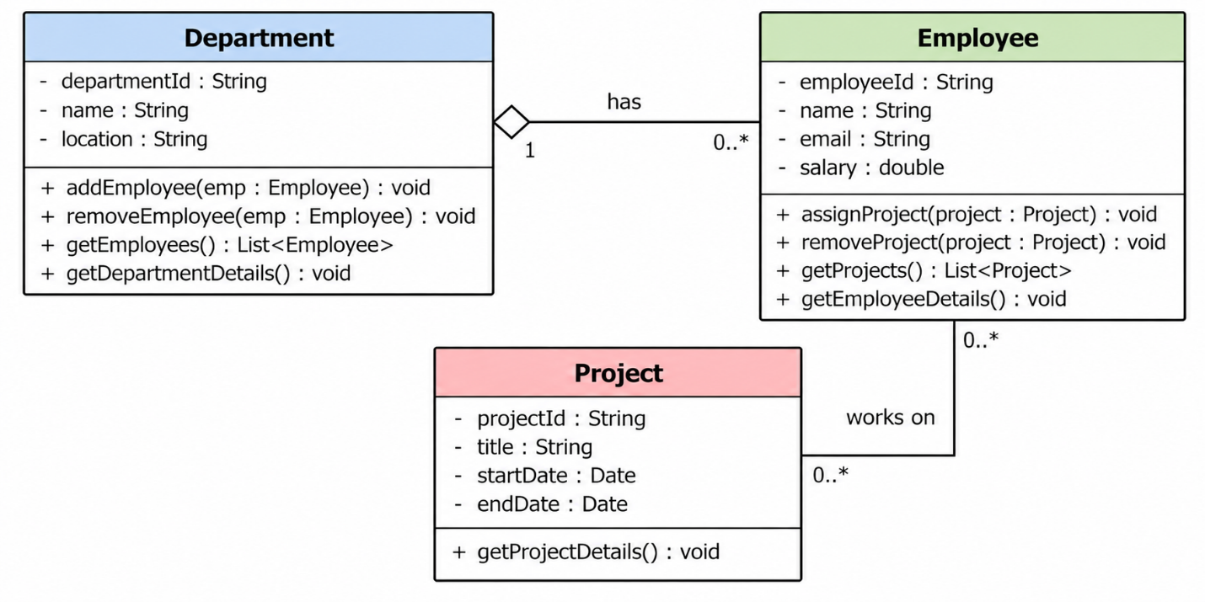
Activity 5
A company is developing a system to manage houses and their rooms.
- A House has a house ID, address, and number of floors.
- A Room has a room number, room type, and area.
- A house contains multiple rooms.
- A room cannot exist independently of its house.
- If a house is demolished, its rooms are also removed.
- The system should allow a house to add a room and remove a room.
- The system should allow users to view the rooms of a house.
